**LINE OF JUNCTION Notice**

## **Party Wall etc. Act 1996 (section 1)**

________________________________________________________________________________________________

To: {{ao_notice_names}}

({{ao_plural}})

of {{ao_correspond_add_horz}}

{{bo_i_we}} {{bo_notice_names}}

({{bo_plural}})

of {{bo_correspond_add_horz}}

as {{bo_plural}} of the land and premises known as

{{bo_property_add_horz}}

which adjoins your premises known as

{{ao_property_add_horz}}

{{bo_I_We}} hereby serve NOTICE on you in your capacity as {{ao_fhlh}}

{{s_15_12_text}}

The accompanying drawings show the proposed works which are:

* {{s1_detail_1}}
* {{s1_detail_2}}

{{bo_I_We}} propose to commence the works after the expiration of one month from the date of service of this notice or earlier if you agree.

**If you, the {{ao_plural}}, do not respond within fourteen days from the service of this Notice, in accordance with the Act, Section 6(7), you shall be deemed to have dissented. Under Section 10 of the Act both parties shall agree in the appointment of one surveyor or each party shall appoint a surveyor.**

In the event of a dispute arising for settlement {{bo_i_we}} would appoint as {{bo_my_our}} surveyor Mr. Steve Whitehead

of {{bos_add_horz}}

*Signed: 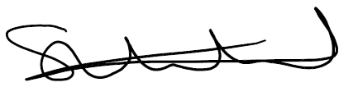

Dated: {{notice_date}}

*Authorised to sign on behalf of the {{bo_plural}}